**Department of Electronics & Communication Engineering**

(Faculty of Technology, Dharmsinh Desai University, Nadiad)

**Academic Year: 2022 - 2023**

**TUTORIAL – 1**

**Subject *:****(ESC101) BASIC ELECTRICAL ENGINEERING*

**Class :**  *B. Tech. Sem.I (EC/CE/IT)*

**Topics :***Temperature dependance of resistance, Kirchhoff current and voltage laws*

1. A coil has a resistance of 21.6 Ω when its mean temperature is 20°C and of24 Ωwhen its mean temperature is 50° C. Find its mean temperature rise, when itsresistance is 25.2 Ω and the surrounding temperature is 16° C.
2. The resistance of a field coil measures 55 Ω at 25° C and 65 Ω at 75° C. Findthe temperature co-efficient of conductor at 0° C.
3. A coil has a resistance of 18 Ω, when its mean temperature is20°C; and 20 Ω, when its mean temperature rise is 50°C. Find its mean temperatureΩrise when its resistance is 21 ohms and the surrounding temperature is 15°C.
4. Find current and voltages across all the resistors.

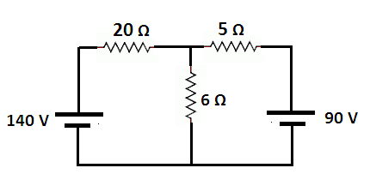

1. Find the current through 20 Ω and 40 Ω resistors.

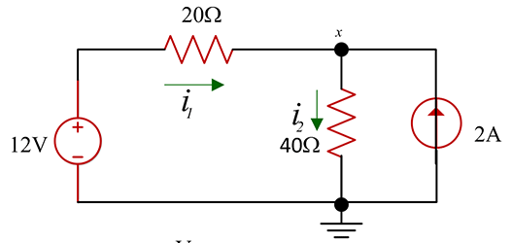

1. Find current i1 for the circuit shown in figure.

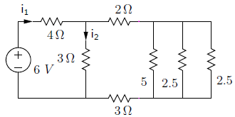

1. Find node voltages in the following circuit.

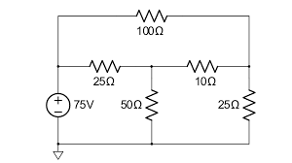

# Prof. Hetal Shah *(*[*shahhetal.ec@ddu.ac.in*](mailto:shahhetal.ec@ddu.ac.in)*)*

# **Prof. J. M. Shah** ([*jmshah.ec@ddu.ac.in*](mailto:jmshah.ec@ddu.ac.in))